

**Regional SALES Analysis**

**By: Shashwat Yadav**

Table of Content

1. Introduction
2. Methodology
3. Requirement Analysis
4. Visuals and their Insights
5. Dashboard and its Insights
6. Conclusion

Introduction:

This introduction section provides an overview of the importance of understanding, outlines the purpose and scope of our analysis.

Sales: In the era of data-driven decision-making, data science has emerged as a critical field, with professionals playing a pivotal role in extracting valuable insights from vast amounts of data about sales of the organization.

Profit: Knowledge of Profit trends enables the management to develop an appropriate strategy for the organization to invest it into a more expanding manner for the organization and its employees.

Limitations of the Dataset:

It is essential to acknowledge the limitations of the dataset. These limitations may include potential biases in data collection, sample representativeness, or missing data points. Additionally, the dataset's coverage may be specific to certain industries, regions, or data collection methodologies, limiting its generalizability. It is crucial to consider these limitations while interpreting the analysis results and drawing conclusions.

Methodology:

In this section, an overview of the methodology employed in the analysis of Sales and Profit of Global Store is provided. Here I outline the data collection process, sources, discuss the data cleaning, and pre-processing techniques applied, and provide an overview of the variables analysed and their significance.

**Data Collection Process and Sources-**

For this analysis, we obtained the dataset from Online Excel File.

**Data Cleaning and Pre-processing Techniques Applied-**

To ensure the dataset's usability and accuracy, we performed a series of data cleaning and pre-processing steps. This involved identifying and converting data types to facilitate accurate analysis. Specific techniques applied include:

**Converting Data Types:** We assessed the data types of each variable and converted them as necessary to ensure accurate analysis. This involved converting numerical variables to the appropriate numeric data types for statistical computations.

**Overview of the Variables Analysed:**

The dataset comprises various variables that were analysed to gain insights into data science salaries. There are three Table given with the data, Orders, Peoples and Return. The key variables analysed from these tables are:

* Orders Table:

|  |  |
| --- | --- |
| Sales | City |
| Segment | Customer Name |
| Order Date | Ship Mode |
| Profit | Order ID |
| State | Quantity |
| Total Sales Income | Total Net Profit |
| Region |  |

Requirement Analysis:

Basically we have used Six Pages for this Analysis:

* On Fist page we have Sales by segment & Sales by month charts.
* On Second Page we have Sales and Profit by State & Sales and Profit by City.
* On Third Page we have only Sales VS Profit by Daily
* On fourth Page we have a mini-dashboard containing Sales by Ship Mode & Profit by month.
* On Fifth Page we have only Sales by State.
* On sixth Page we have a Full Dashboard of Regional Sales Analysis containing all the above Charts, Cards, Slicer and other Visuals together on a single page.

Visuals and their Insights:

Sales Analysis (Page-1):

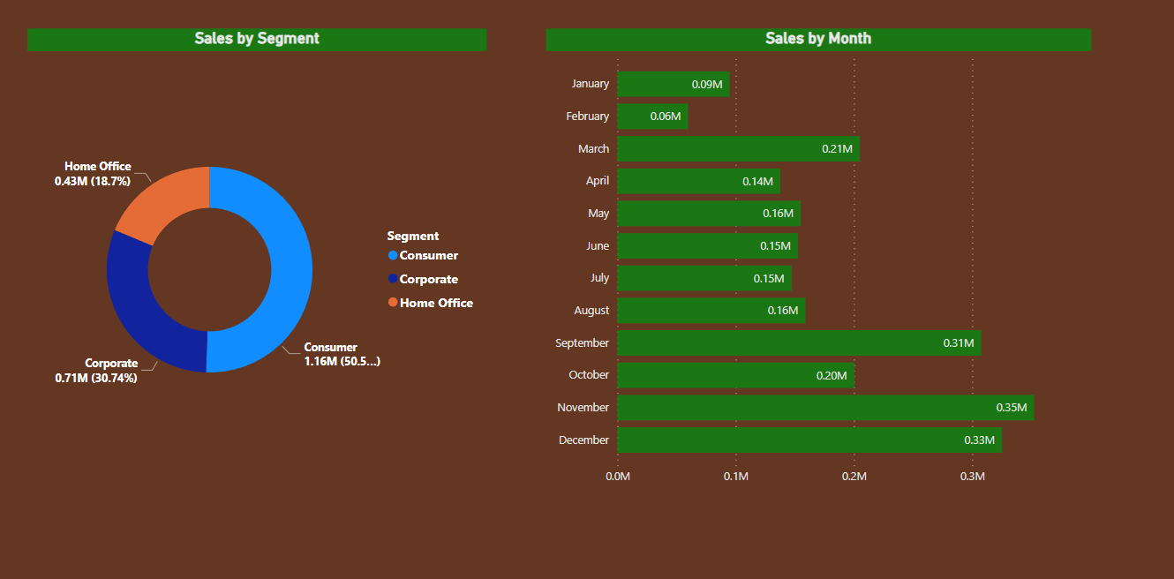

In this page as you can see there are 2-Charts presented, now we will explain all the information we get from these visuals of Data-

**2-Charts:**

|  |
| --- |
| **First Chart is a Donut Chart containing the data of (Sales by Segment)**  in which segment is given as legends in the chart and gives us the figures that consumer has 50.56% (11,61,401.35 $), Corporate has 30.74% (7,06,146.37 $) and Home Office has 18.7% (4,29,653.15 $). |
| **Second Chart is a Clustered Bar Chart containing the data of (Sales by Month)**  in which Months is shown in Y-axis and Sales is shown in X-axis giving the visuals through bar that every month, how much sales is done. |

Sales Analysis (Page-2):

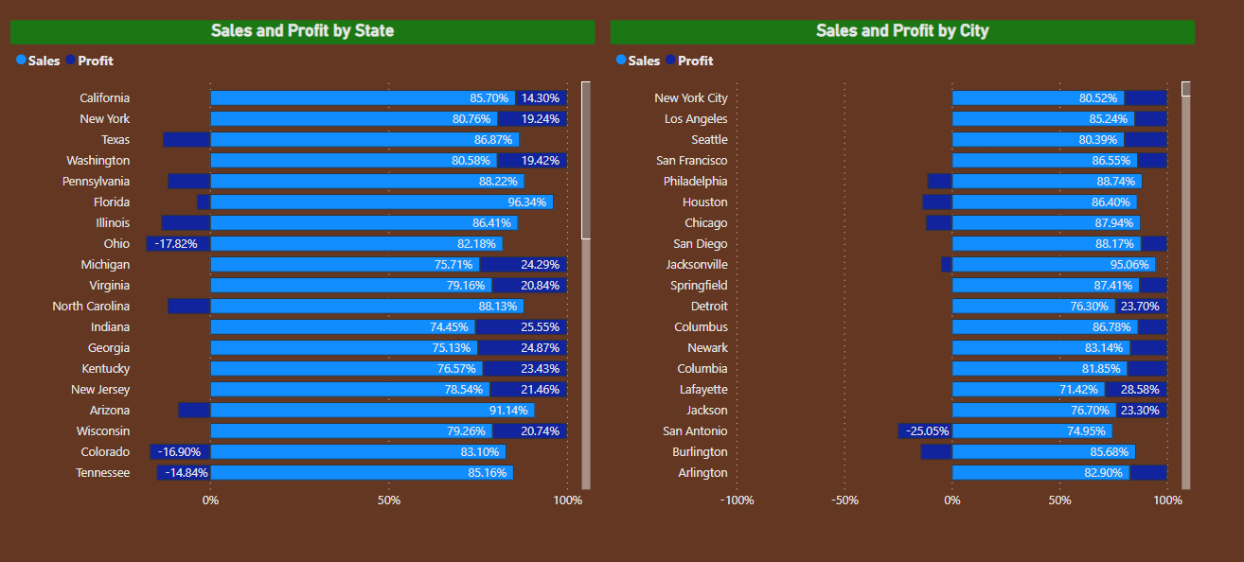

In this page as you can see there are 2-Charts presented, now we will explain all the information we get from these visuals of Data-

**2-Charts:**

|  |
| --- |
| **First Chart is a Stacked Bar Chart containing the data of (Sales and Profit by State)**  in which states are shown in Y-axis where Sales and Profit are shown in X-axis giving the visuals through Stacked bar that, how much sales and Profit is done by every state. |
| **Second Chart is a Stacked Bar Chart containing the data of (Sales and Profit by City)**  in which City are shown in Y-axis where Sales and Profit are shown in X-axis giving the visuals through Stacked bar that, how much sales and Profit is done by every City. |

Sales Analysis (Page-3):

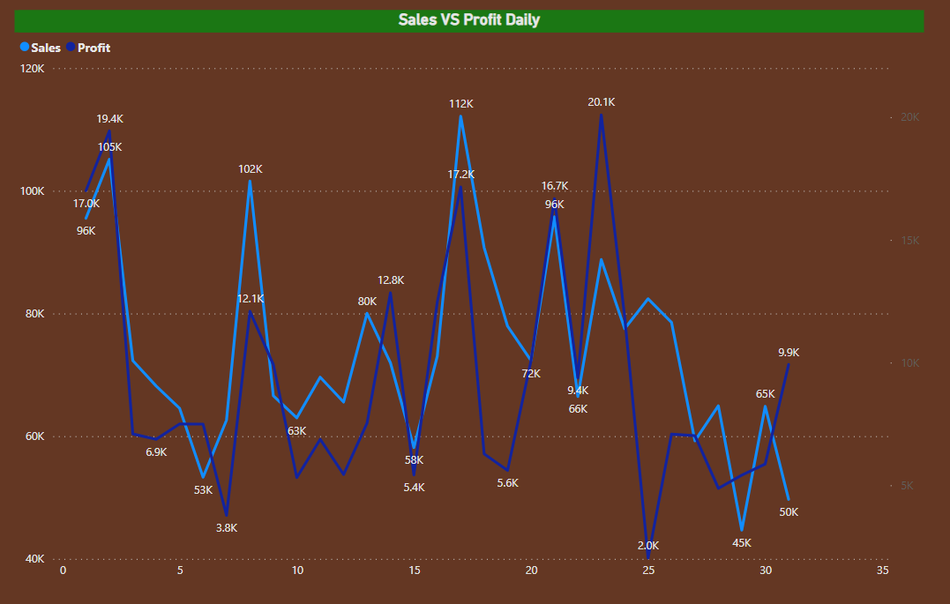

In this page as you can see there is only a single Chart presented, now we will explain all the information we get from this visual of Data-

**1-Chart:**

|  |
| --- |
| **Chart is a Line Chart containing the data of (Sales Vs Profit Daily)**  in which states are shown in Left Y-axis whereas on Right Y-axis Profit are shown and on X-axis days are shown giving the visuals through lines that, how much sales and Profit is done on daily basis. |

Sales Analysis (Page-4):

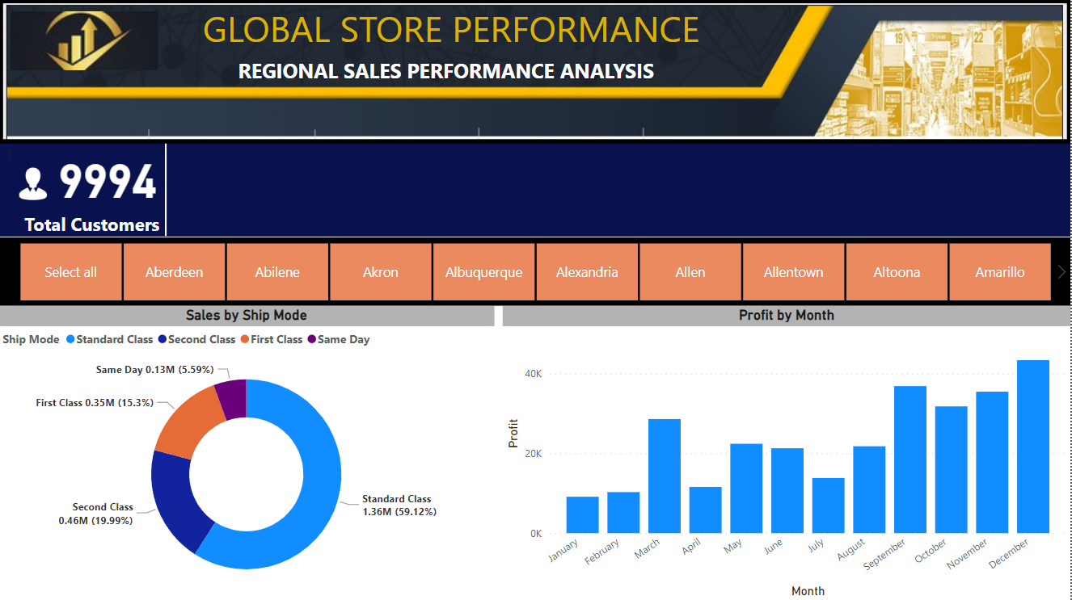

In this page as you can see there is a Card, a Slicer and 2-Charts presented, now we will explain all the information we get from these visuals of Data-

**Dashboard:**

|  |
| --- |
| On top left of the dashboard a Card is showing the Total Number of customers. |
| Below the Card there is a Slicer showing the different cities so that the data can be filter out for the particular city which is being selected. |
| Below the Slicer on the bottom left side on the dashboard there is a Donut Chart containing the data of (Sales by Ship Mode) in which Ship Mode is given as legends where Standard Class has 59.12% (13,58,215.74 $), Second Class has 19.99% (4,59,193.57 $), First Class has 15.3% (3,51,428.42 $) and Same Day has 5.59% (1,28,363.13 $). |
| Below the Slicer on the bottom Right side on the dashboard there is a Clustered Column Chart containing the data of (Profit by Month) in whichProfit is shown in Y-axis and moths are shown in X-axis hence giving the visuals of Profit of every month. |

Sales Analysis (Page-5):

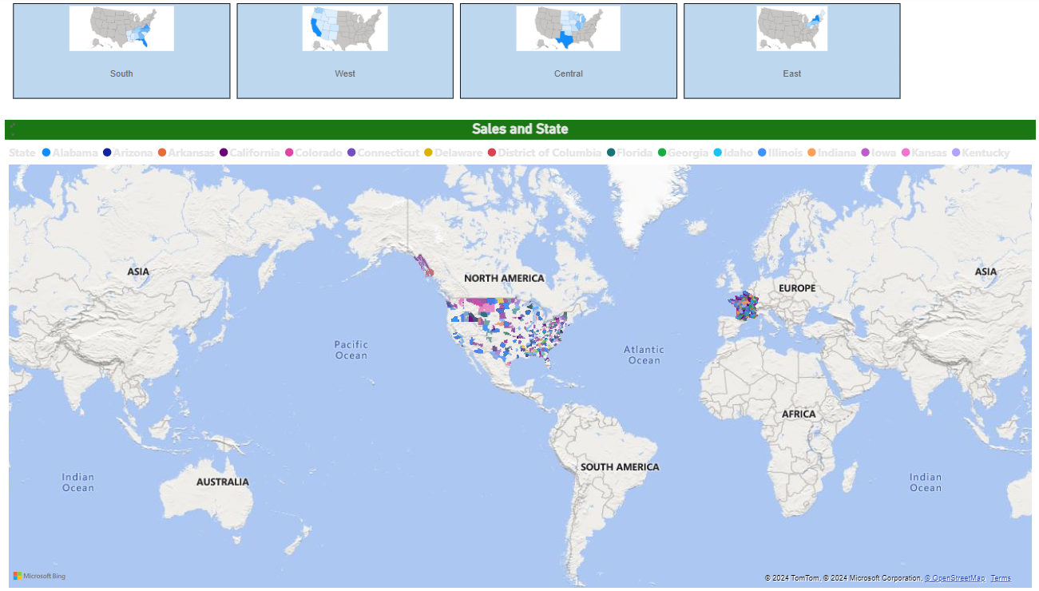

In this page as you can see there is a Slicer and a Chart presented, now we will explain all the information we get from these visuals of Data-

**1-Slicer:**

|  |
| --- |
| On top of the page there is a Slicer showing the different Regions so that the data can be filter out for the particular Region which is being selected. |

**1-Chart:**

|  |
| --- |
| Below the Slicer Filled Map Chart containing the data of (Sales and states) in which States are given as legends, On the basis of the selection of the region through the slicer the map chart will shows the data sales and state. |

Dashboard and its Insights:

Dashboard (Page-6):

Regional Sales Analysis-

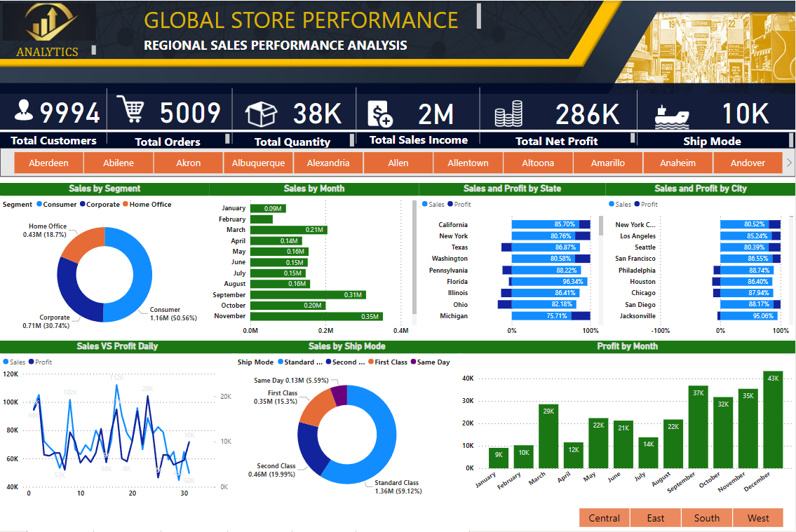

In this page as you can see there are 6-Cards, 2-Slicer and 7-Charts. Now we will explain all the information we get from these visuals of data-

**Dashboard:**

|  |
| --- |
| On top left of the dashboard there are 6 -Cards showing the:  Total Number of Customers – 9994 (Approx. 10K)  Total Number of Distinct Orders – 5009 (Approx. 5K)  Total Quantity – Approx. 38K  Total Sales Income – Approx. 2 Million  Total Net Profit – Approx. 286K  Total Number of Ship Mode – 10K |
| Below the Cards there is a Slicer showing the different cities so that the data can be filter out for the particular city which is being selected. |
| Below the Slicer:   * On the middle left side on the dashboard there is a Donut Chart containing the data of (Sales by Segment) in which segment is given as legends in the chart and gives us the figures that consumer has 50.56% (11,61,401.35 $), Corporate has 30.74% (7,06,146.37 $) and Home Office has 18.7% (4,29,653.15 $). * On the middle of the dashboard there is a Clustered Bar Chart containing the data of (Sales by Month) in which Months is shown in Y-axis and Sales is shown in X-axis giving the visuals through bar that how much sales are done every month. * On the middle after the sales by month chart in the dashboard there is a Stacked Bar Chart containing the data of (Sales and Profit by State) in which states are shown in Y-axis where Sales and Profit are shown in X-axis giving the visuals through Stacked bar that, how much sales and Profit is done by every state. * On the middle right on the dashboard there is a Stacked Bar Chart containing the data of (Sales and Profit by City) in which Cities are shown in Y-axis where Sales and Profit are shown in X-axis giving the visuals through Stacked bar that, how much sales and Profit is done by every City. * On the Bottom left side on the dashboard there is a Line Chart containing the data of (Sales VS Profit Daily) in which states are shown in Left Y-axis whereas on Right Y-axis Profit are shown and on X-axis days are shown giving the visuals through lines that, how much sales and Profit is done on daily basis. * On the Bottom middle of the dashboard there is a Donut Chart containing the data of (Sales by Ship Mode) in which Ship Mode is given as legends where Standard Class has 59.12% (13,58,215.74 $), Second Class has 19.99% (4,59,193.57 $), First Class has 15.3% (3,51,428.42 $) and Same Day has 5.59% (1,28,363.13 $). * On the Bottom Right of the dashboard there is a Clustered Column Chart containing the data of (Profit by Month) in whichProfit is shown in Y-axis and moths are shown in X-axis hence giving the visuals of Profit of every month. |
| Below the Bottom Right Chart there is a Slicer containing the Region (Central, East, South, West), so that the data can be filter out for the particular region which is being selected. |

Conclusion:

* We have:

1. Segment wise sales
2. Sales according to months
3. Sales and Profit according to State
4. Sales and Profit according to City
5. Sales VS Profit on Daily basis
6. Sales by Ship mode
7. Profit according to months
8. Map representation of region state and city of Sales

* Total Number of Customers – 9994
* Total Number of Distinct Orders – 5009
* Total Number of Quantity – Approx. 38K
* Total Sales Income – Approx. 2M
* Total Net Profit - Approx. 286K
* Total Number of Ship mode - Approx. 10K

These figures are only showing the data without applying any filters it may change on the basis of filters given in the slicers on the dashboard and will also changes the visuals of the data.